MODULE 3&4

Assignment 1: Short Answer Questions
- Use of heading tags <h1> to <h6>
They are used to define headings in different sizes and show content hierarchy.
- Difference between <h1> and <h6>
<h1> is the largest and most important heading, while <h6> is the smallest.
3.Purpose of the <p> tag
It is used to define a paragraph of text.
4.Difference between <br> and <hr>
<br> inserts a line break, while <hr> inserts a horizontal line.
5.Difference between <b> and <strong>
<b> makes text bold, while <strong> shows strong importance
6.Difference between <i> and <em>
<i> makes text italic, while <em> gives emphasis with meaning.
7.Use of <mark> tag
It is used to highlight text.
8.Use of <small> tag in real websites
Used for copyright text, disclaimers, or notes.
9.Use of <del> tag
It shows deleted or removed text with a line through it.
10.Use of <sup> and <sub> (with example)
<sup> displays superscript text (10<sup>2</sup>)
<sub> displays subscript text (H<sub>2</sub>O)

Assignment 2: Identify the Output
Write the output of the following HTML code:
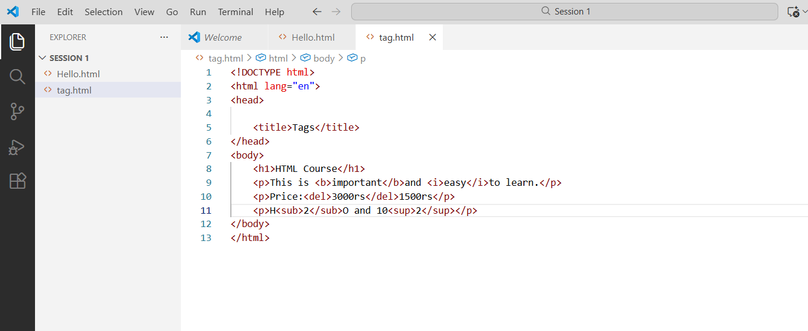
OUTPUT:
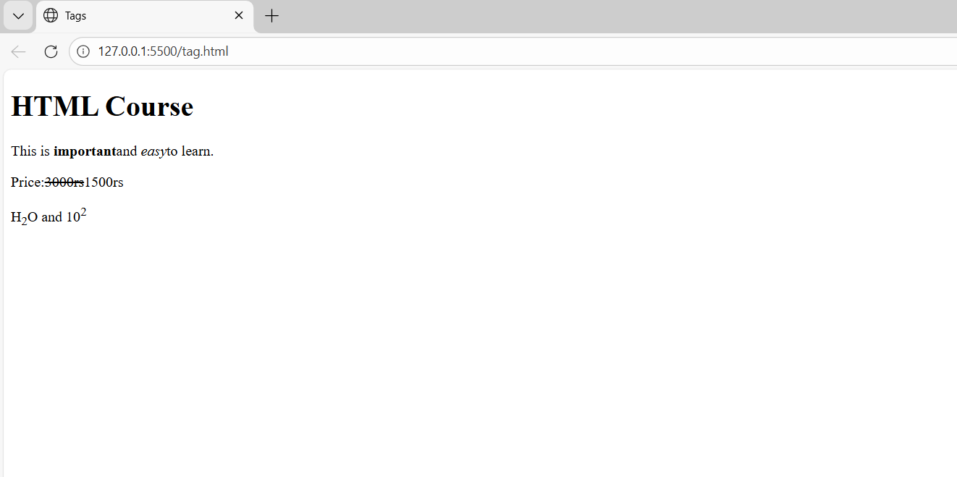
Output will be:
HTML Course (as a big heading)
Text: This is important and easy to learn.
Price: ₹1500
H₂O and 10²

Assignment 3: Practical Task Create an HTML page that includes:

Create an HTML page that includes:
- One <h1> Heading and two subheadings
- Two Paragraphs using <p>
- A line break using <br>
- A horizontal line using <hr>
- Use at least 5 formatting tags from the following :
<b>,<strong>,<i>,<em>,<mark>,<small>,<del>,<sup>,<sub>
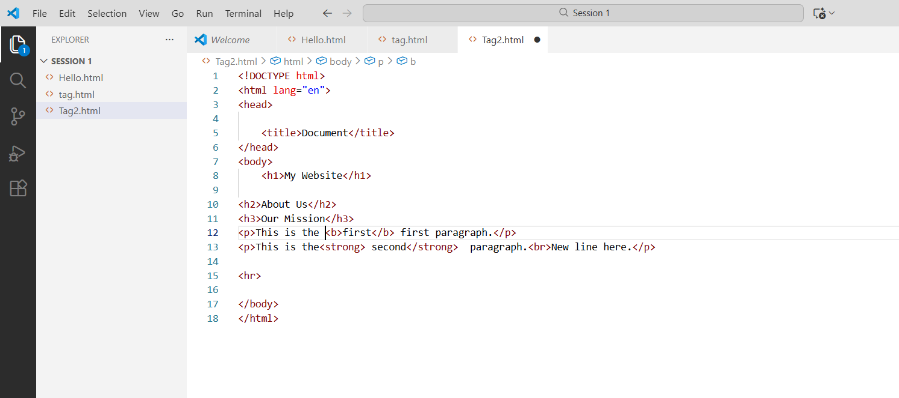
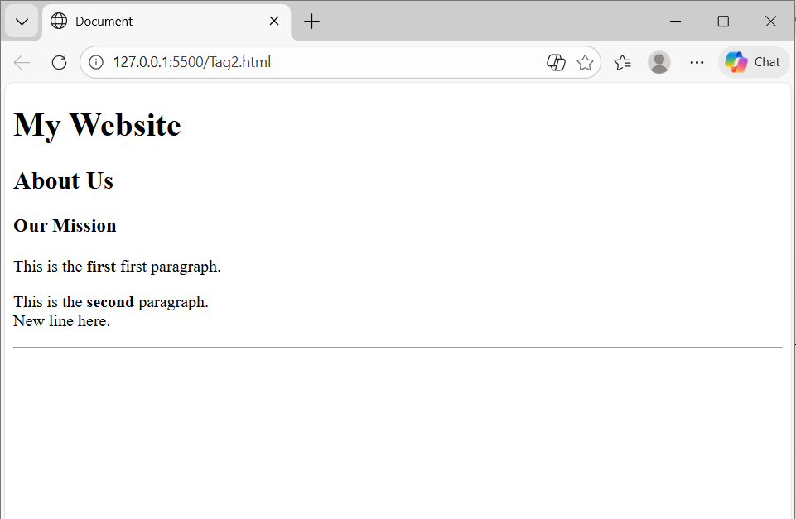
Assignment 4: Short Answer Questions

1.What is an anchor tag?
Anchor tag (<a>):
Used to create hyperlinks to other webpages, files, or sections of the same page.

2 • What is the syntax of the tag?
Syntax:
<a href="URL">Link Text</a>
3.Difference between absolute and relative paths:
Absolute path = full URL; Relative path = path relative to current file.
4.Example of an absolute path:
https://www.google.com
5.Example of a relative path:
images/photo.jpg
6.Use of <img> tag:
To display images on a webpage.
7.Why alt attribute is important:
Shows text if image doesn’t load and helps screen readers.
- Use of width and height attributes:
To set image size.
- Open a link in a new tab:
Use target="_blank".
- Image link:
An image that works as a clickable link.

Assignment 5: Fill in the Blanks
- The tag used to create a hyperlink is <a>.
- The a ribute that specifies the image path is src.
- The a ribute used to open a link in a new tab is target=”_blank”.
- The text shown when an image does not load is called alt text.
- The tag used to display an image is <img>.

Assignment 6: Practical Task
Create an HTML Page That include :
- One external link to Google
- One internal link to another HTML page
- One image with src, alt, width, and height
- One image used as a clickable link
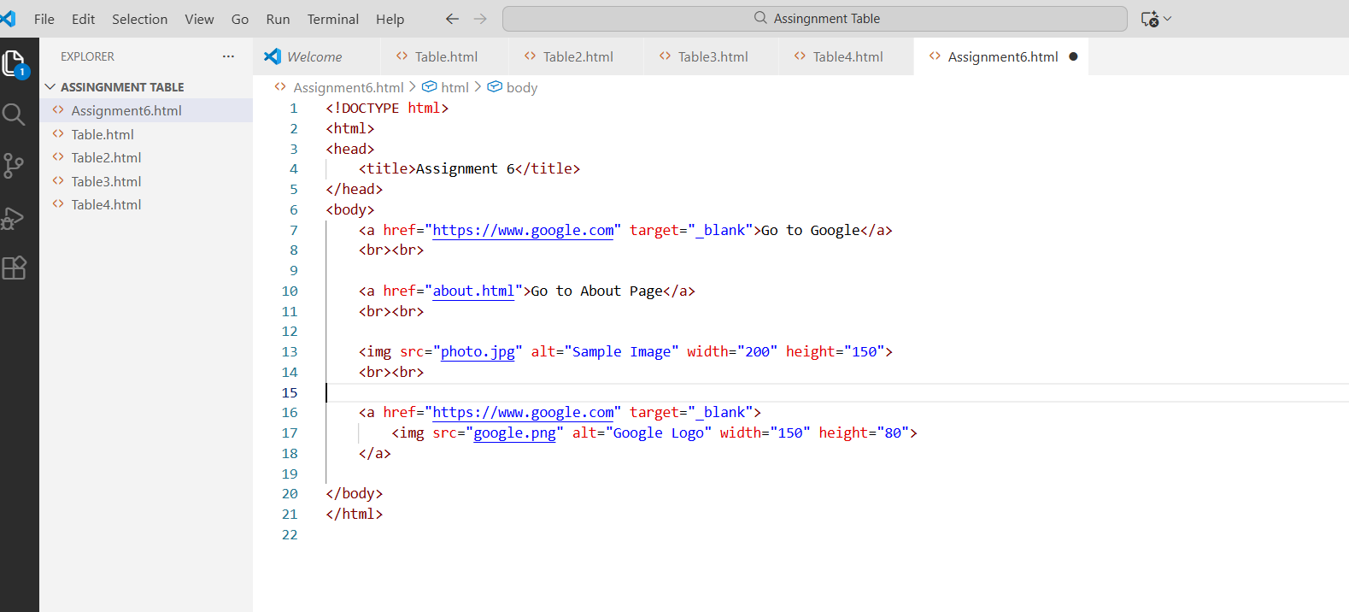

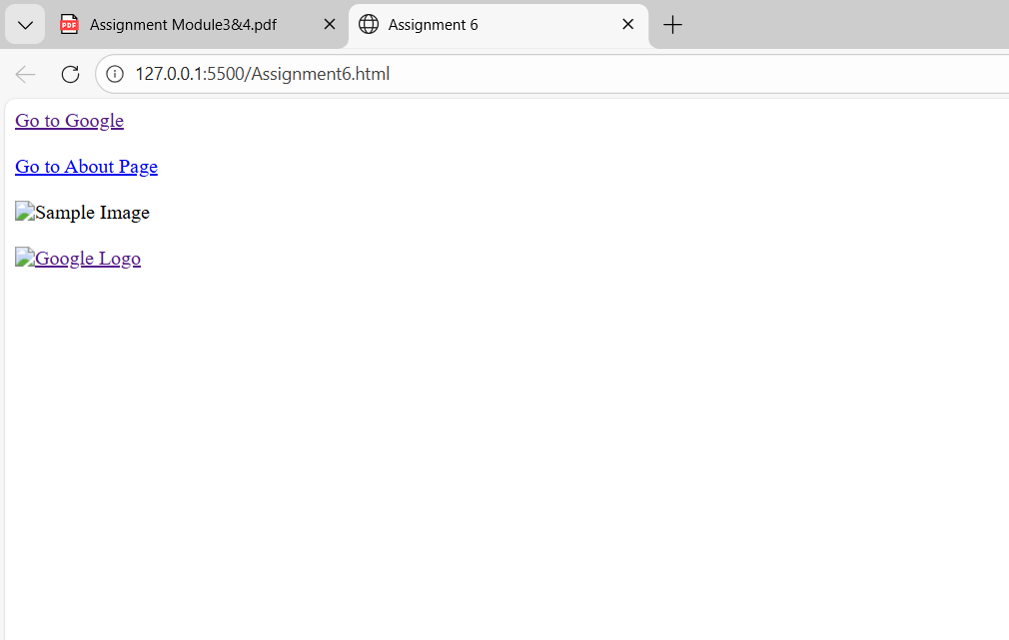

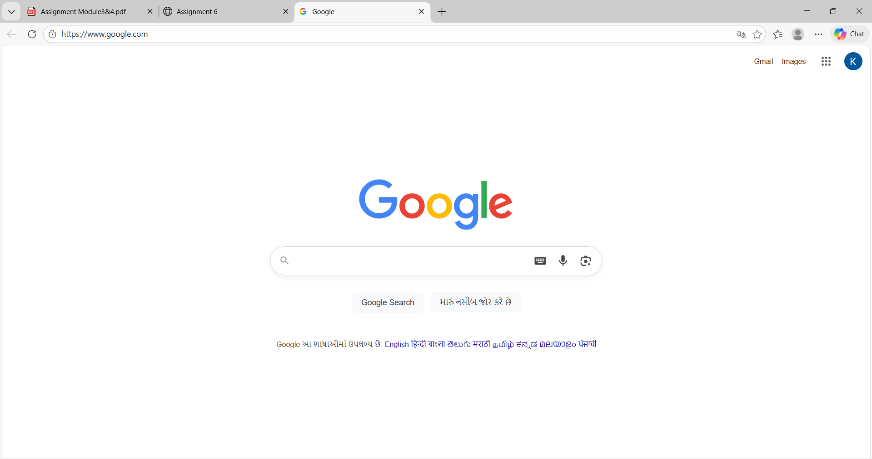

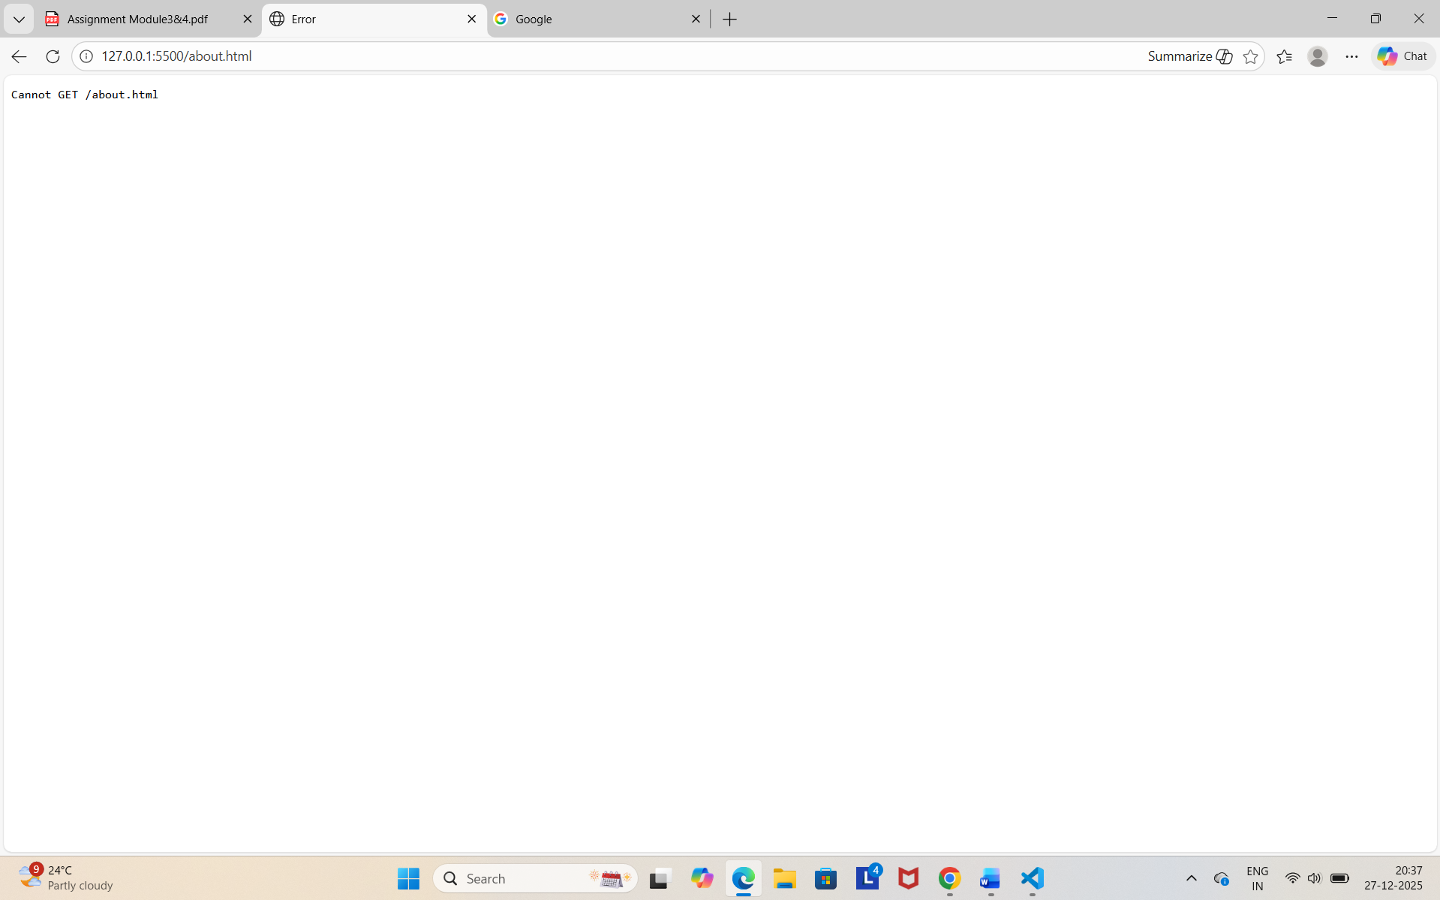

Assignment 7: Error Identification
Find and correct the errors:
<a>Visit Google </a>
<img href=”photo.jpg”>
<a href=”home.html”>
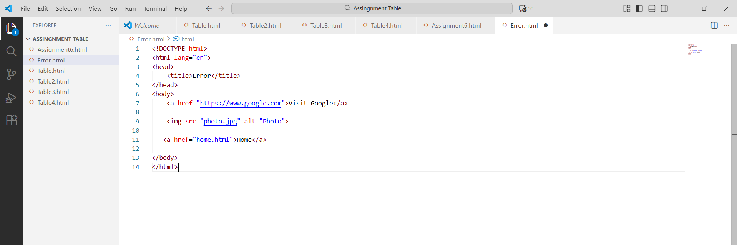
Output:
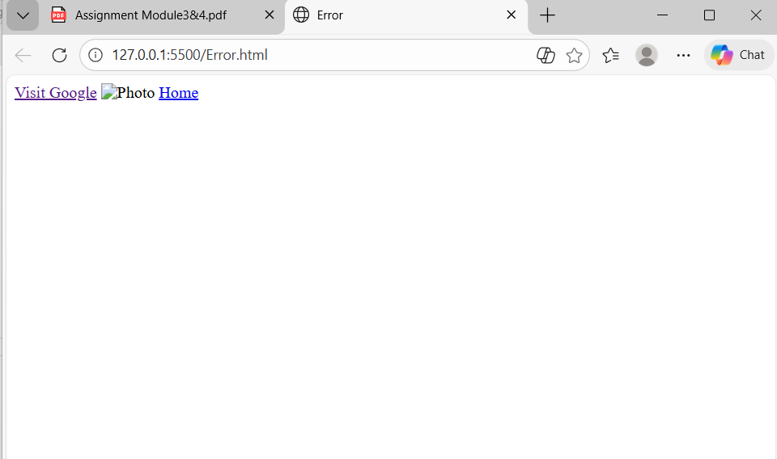

Assignment 8: Real-Life Scenario

You are crea ng a college website
1. Where will you use hyperlinks on the website?
Hyperlinks will be used in the navigation menu (Home, About Us, Courses, Admissions, Contact), faculty profiles, notice board, results, online admission form, and external links like university and scholarship portals.

2. Where will you use images?
Images will be used on the homepage banner, college campus photos, principal and faculty photos, event gallery, laboratories, library, and student activities sections.

3. Which paths will you use for internal pages and why?
Relative paths will be used for internal pages because they make the website portable, easy to manage, and work correctly even if the site is moved to another server or folder.
Example:
<a href="about.html">About Us</a>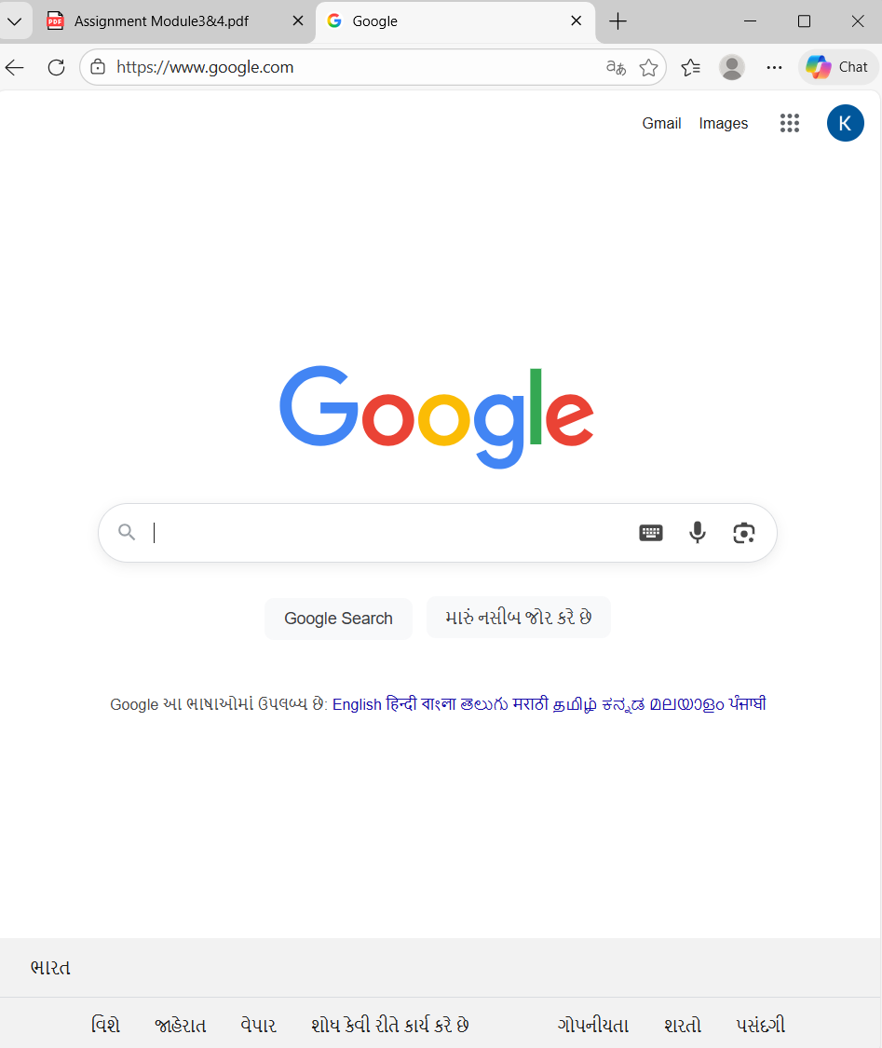
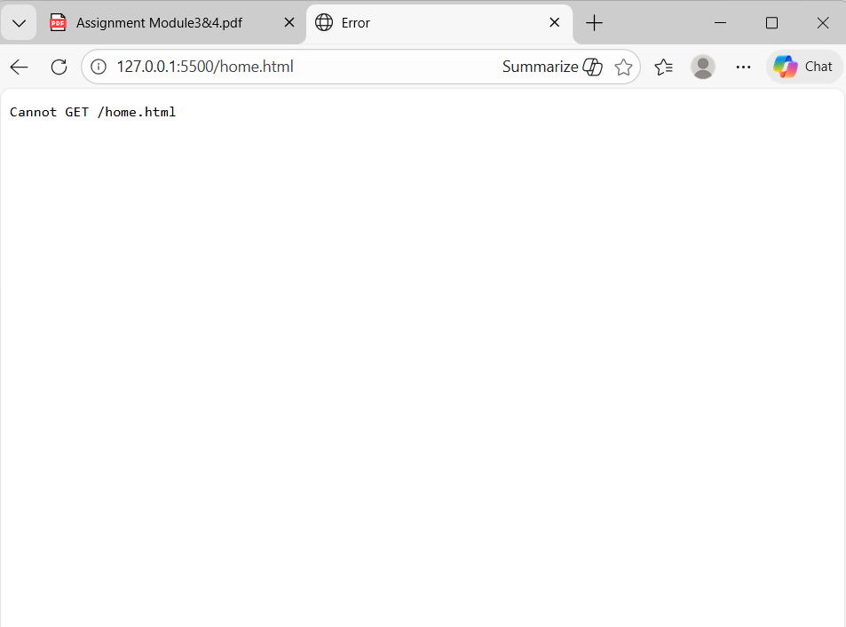

Assignment 9: Interview-Oriented Questions

1. Why should only one <h1> be used per page
<h1> represents the main heading of the page. Using one <h1> improves SEO, accessibility, and keeps the content structure clear.

2. What happens if the alt attribute is missing?
If alt is missing, screen readers cannot describe the image, and the image meaning is lost if it fails to load, reducing accessibility and SEO.

3. Can an image be used as a link? Explain how.
Yes. An image can be used as a link by placing the <img> tag inside an <a> tag.
Example:
<a href="home.html">
<img src="logo.png" alt="Home">
</a>

4. Why are relative paths preferred in real projects?
Relative paths are preferred because they are portable, easy to maintain, and work even when the website is moved to another server or folder.

